Website:

“CARE”



Online Post Office Management System

# PROJECT GROUP MEMBERS

|  |  |
| --- | --- |
| **Students Id** | **Student Name** |
| **Student1417959** | **Moiz Khan** |
| **Student1424628** | **Ifra Khan** |
| **Student1424612** | **Hanzala Khan** |
| **Student1425119** | **Asad Afza** |

**CURRICULUM BATCH**

**6740 2210B3**

# FACULTY

**Sir. Ebad Uddin Ahmed**

# CO-ORDINATOR

**MS. Munazzah**

Online Post Office Management System

**SCREEN SHOTS**

Online Post Office Management System

# Patient Register

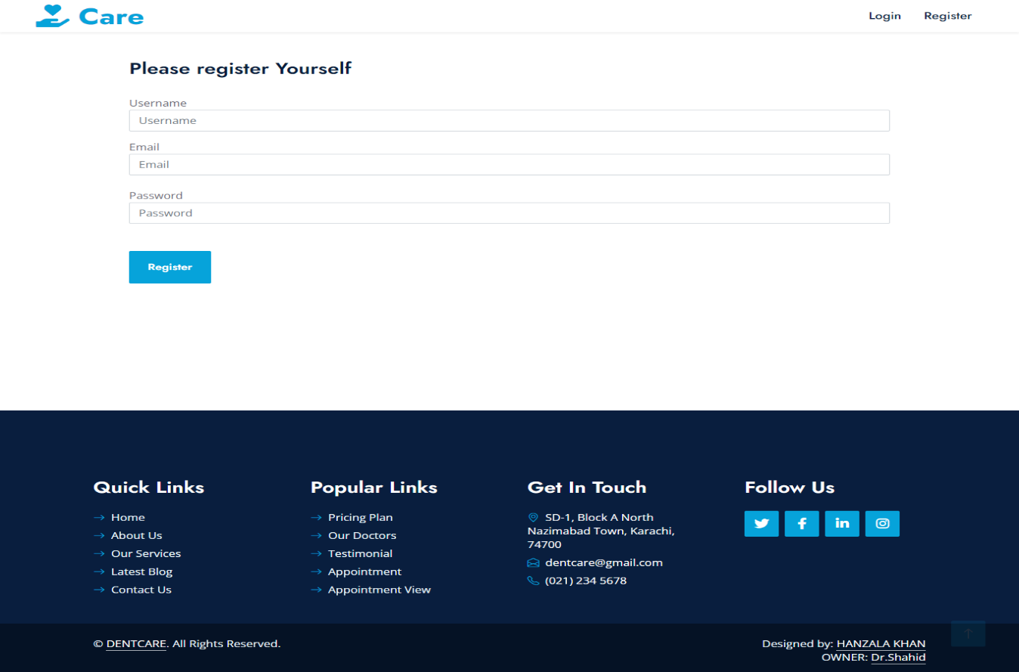

# Appointment

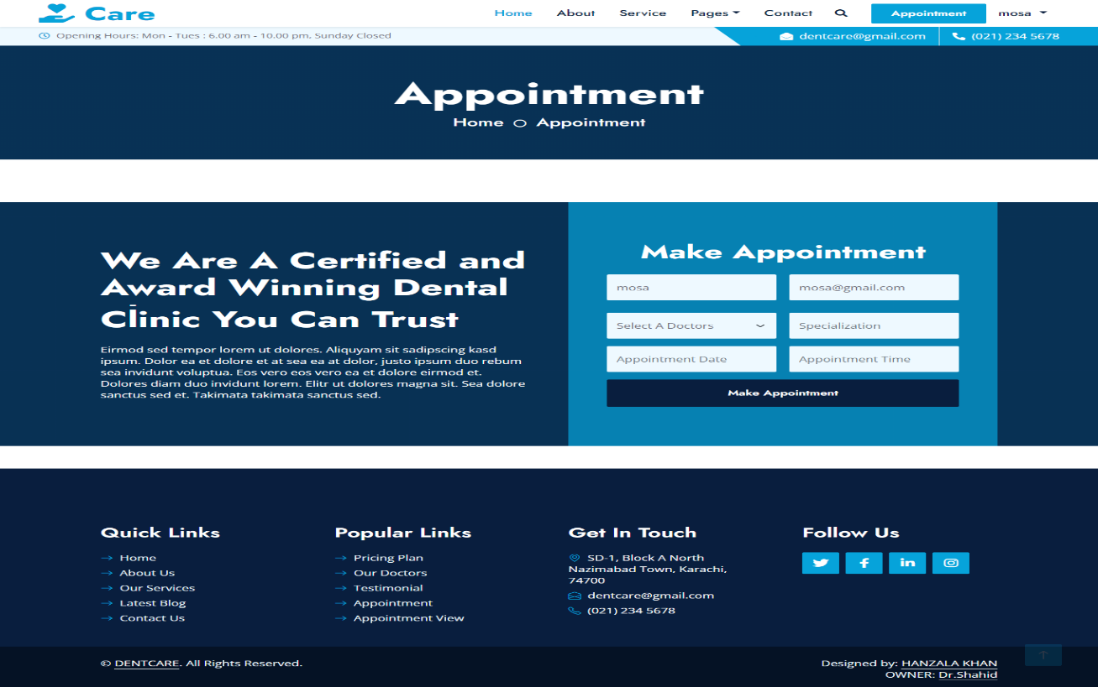

Online Post Office Management System

# View Appointment

# 

# About Us

# 

Online Post Office Management System

**Service**



# Home Page

# 



Online Post Office Management System

# Footer

# 

# Patient Login

# 

**TESTIMONIAL**

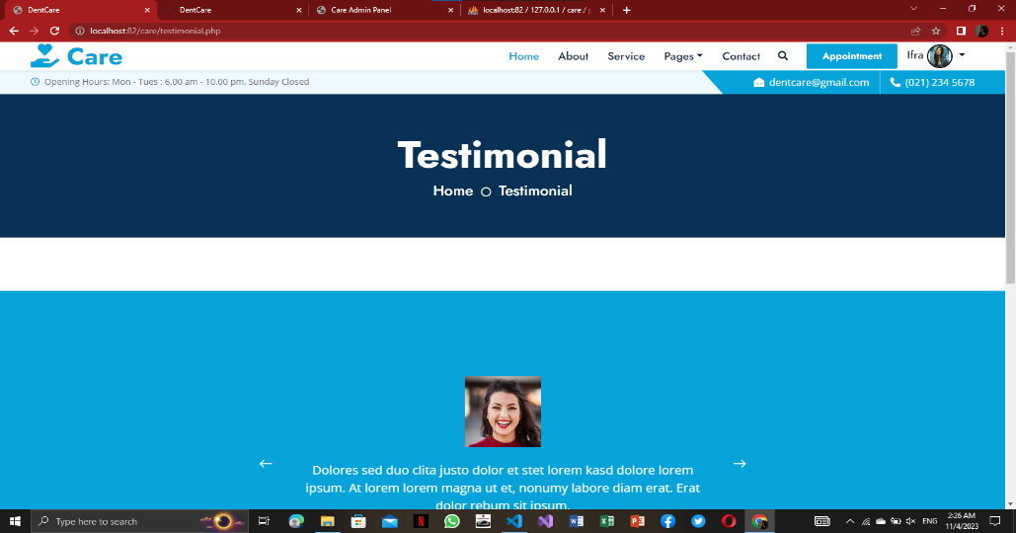

Online Post Office Management System

# 

**Contact Us**

# Search Bar

# 

Online Post Office Management System

**Doctors**

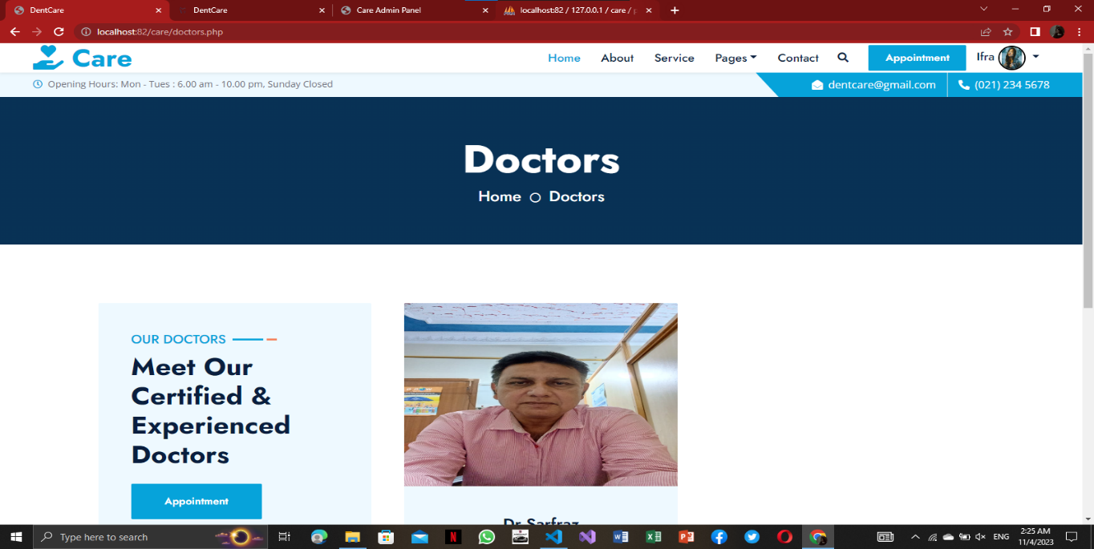

Blog

# 

Online Post Office Management System

# ADMIN SCREENSHOTS

# 404

# 

# Blog

# 

# CHANGE PASSWORD

# 

**CITY**

# 

# Doctor

# 

# Header

# 

**HOME**

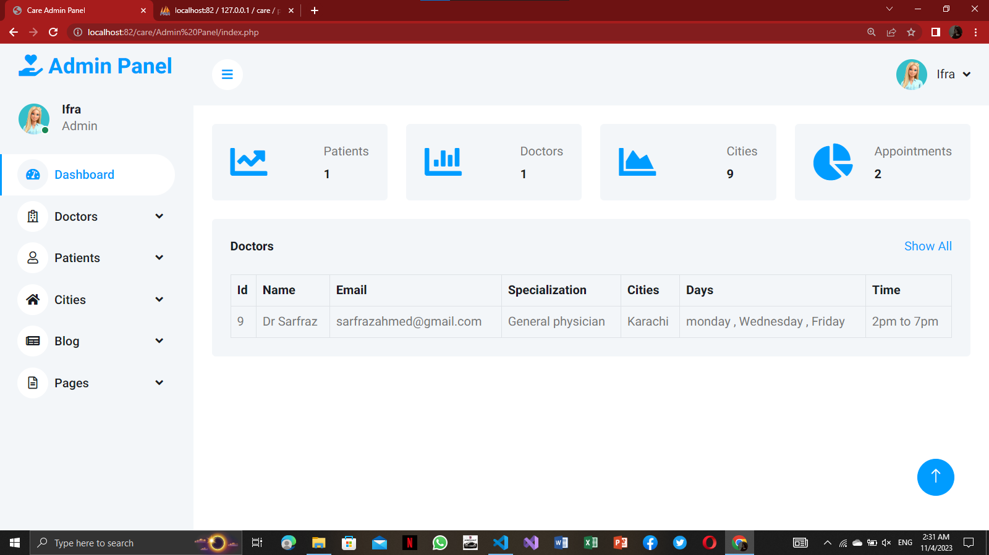

**Patient**

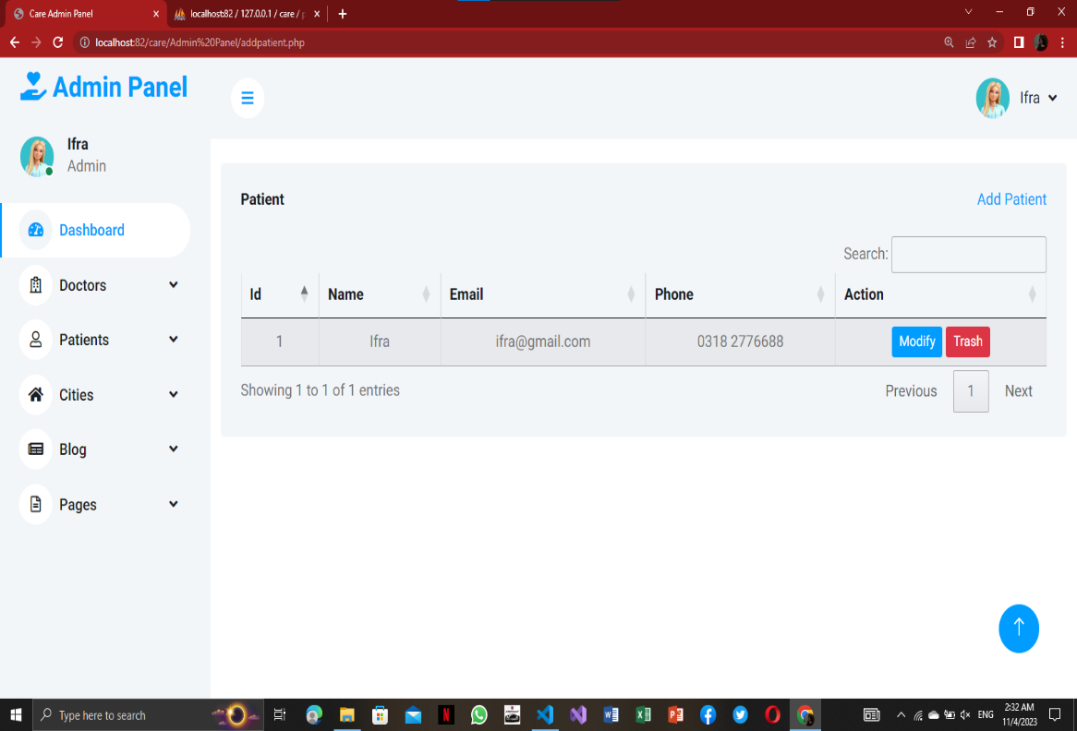

**Profile**

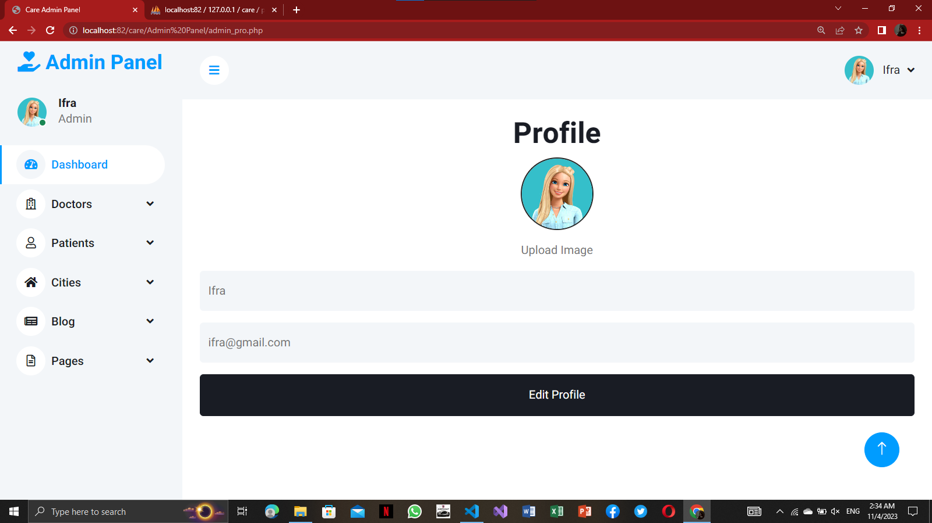

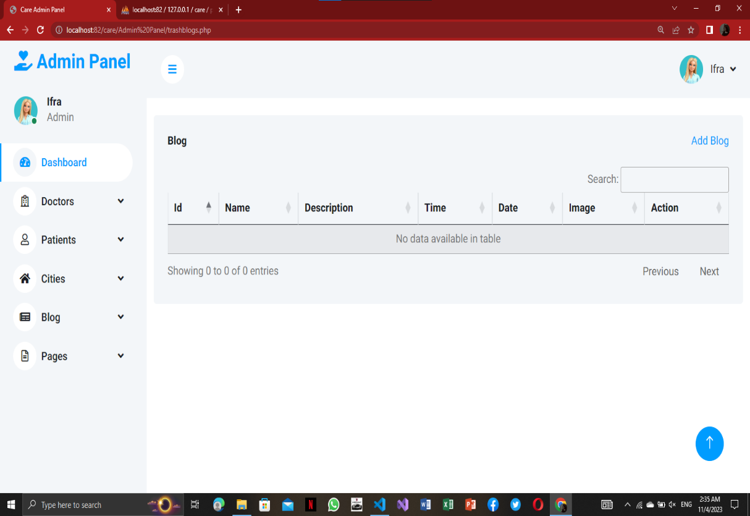**Trash Blog**

**Trash City**

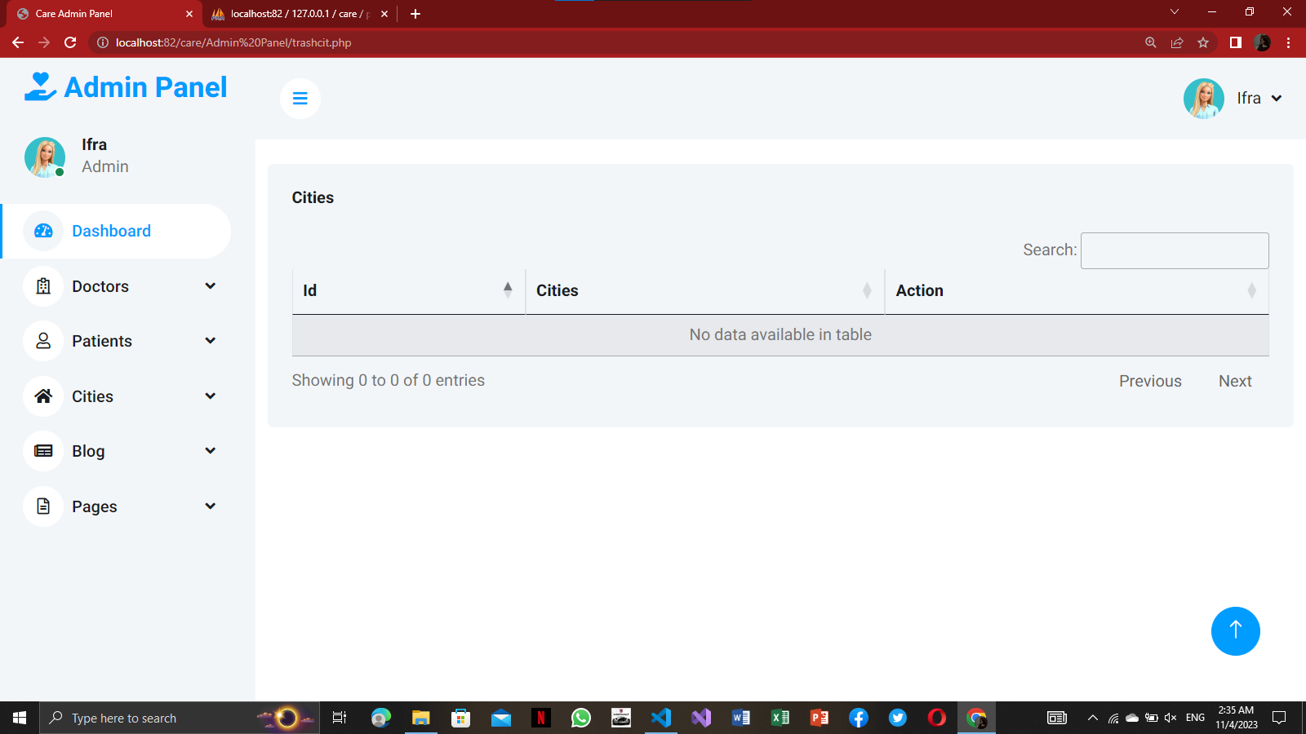

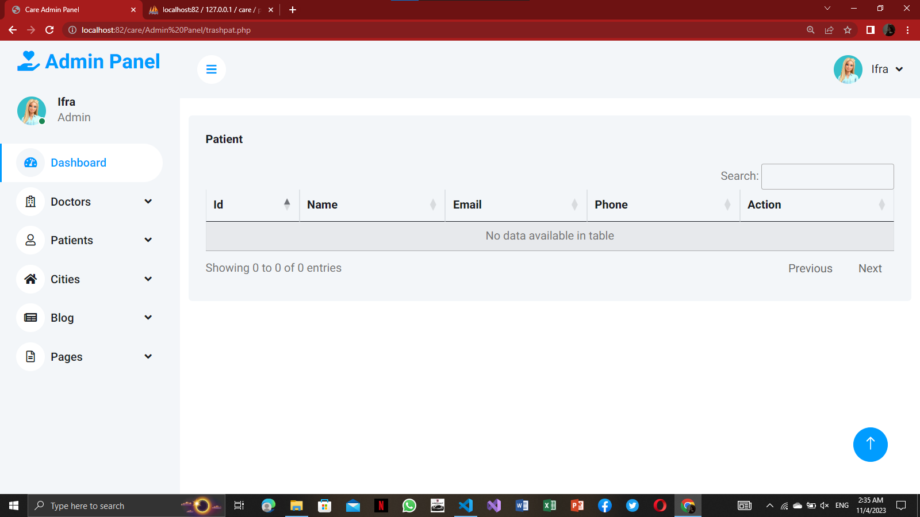**Trash Patient**

**Trash Doctor**

